

**Placement Empowerment Program**

***Cloud Computing and DevOps Centre***

# POC 4: Create a Simple Backup Script

## Create a script that backs up your entire Git repository to a local folder daily

Name: Manashaa U Department:CSE



# Introduction

By creation a local git repository, each developer gets their own local repository, complete with a full history of commits. Having a full local history makes Git fast, since it means you don't need a network connection to create commits, inspect previous versions of a file, or perform diffs between commits

# Step-by-Step Overview

## Step 1

Check if your system has git installed else Download git your sytem

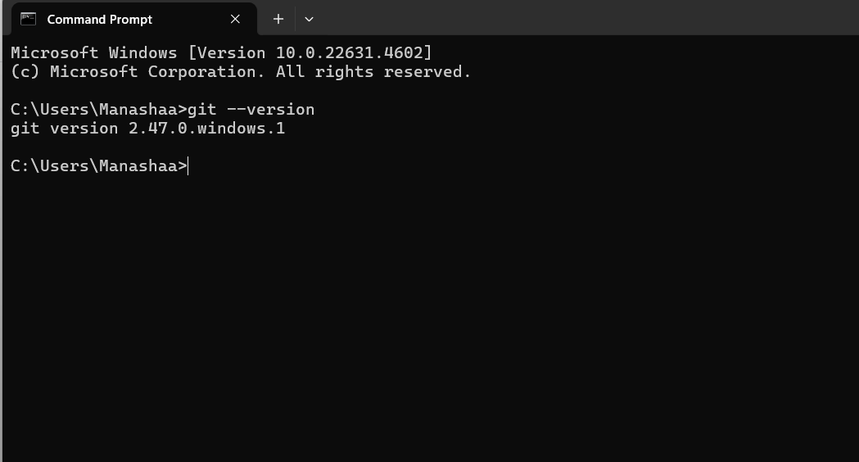

## Step 2

Open notepad and type the following code

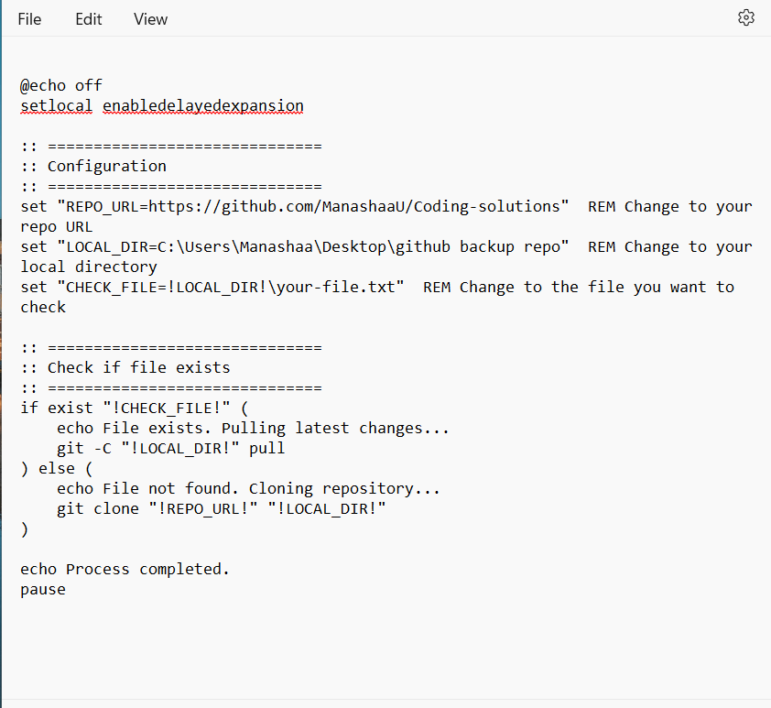

## Step 3 :

Save it with “.bat” extension

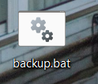

## Step 4

Create a folder for backup

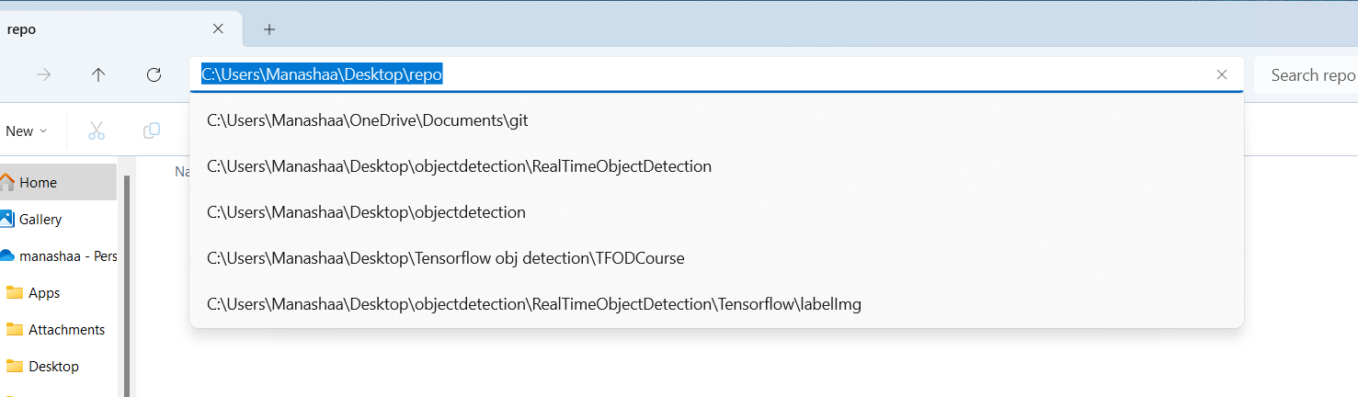

## Step 5

Open task manager, create a new basic task and a wizard will guide the setup .enter name ,description and time ,then enter the code in the “.bat”extension file by clicking in “browse”.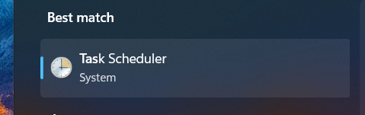

## Step 6

An automatic backup system has been created

# Outcome

A local repository is a copy of the entire project's history and codebase that resides on a developer's machine. When a developer initializes a local repository, Git sets up the necessary infrastructure to track changes, branches, and commits within the project .We can create a local repository by the following commands